There’s nothing new under the sun ?

Hi Freaks.

As a further development of the Opto Circuit, I thought I would bring you up to speed with the current state of my experimental research.

Suppose it were possible to design and build a Solar Tracker Circuit for less than $2 , who wouldn’t be interested in hearing more about this ?

What if this circuit could output the current position of the sun in Degrees with an accuracy of 1 part in 256 using an 8 Bit and 1 part in 1024 using a 10 Bit A2D ?

If, in addition, the Circuit could output the total incident sunlight falling on the 4 compass Headings, would that not make this circuit almost irresistible ?

Perhaps the Hardware could look like this ?

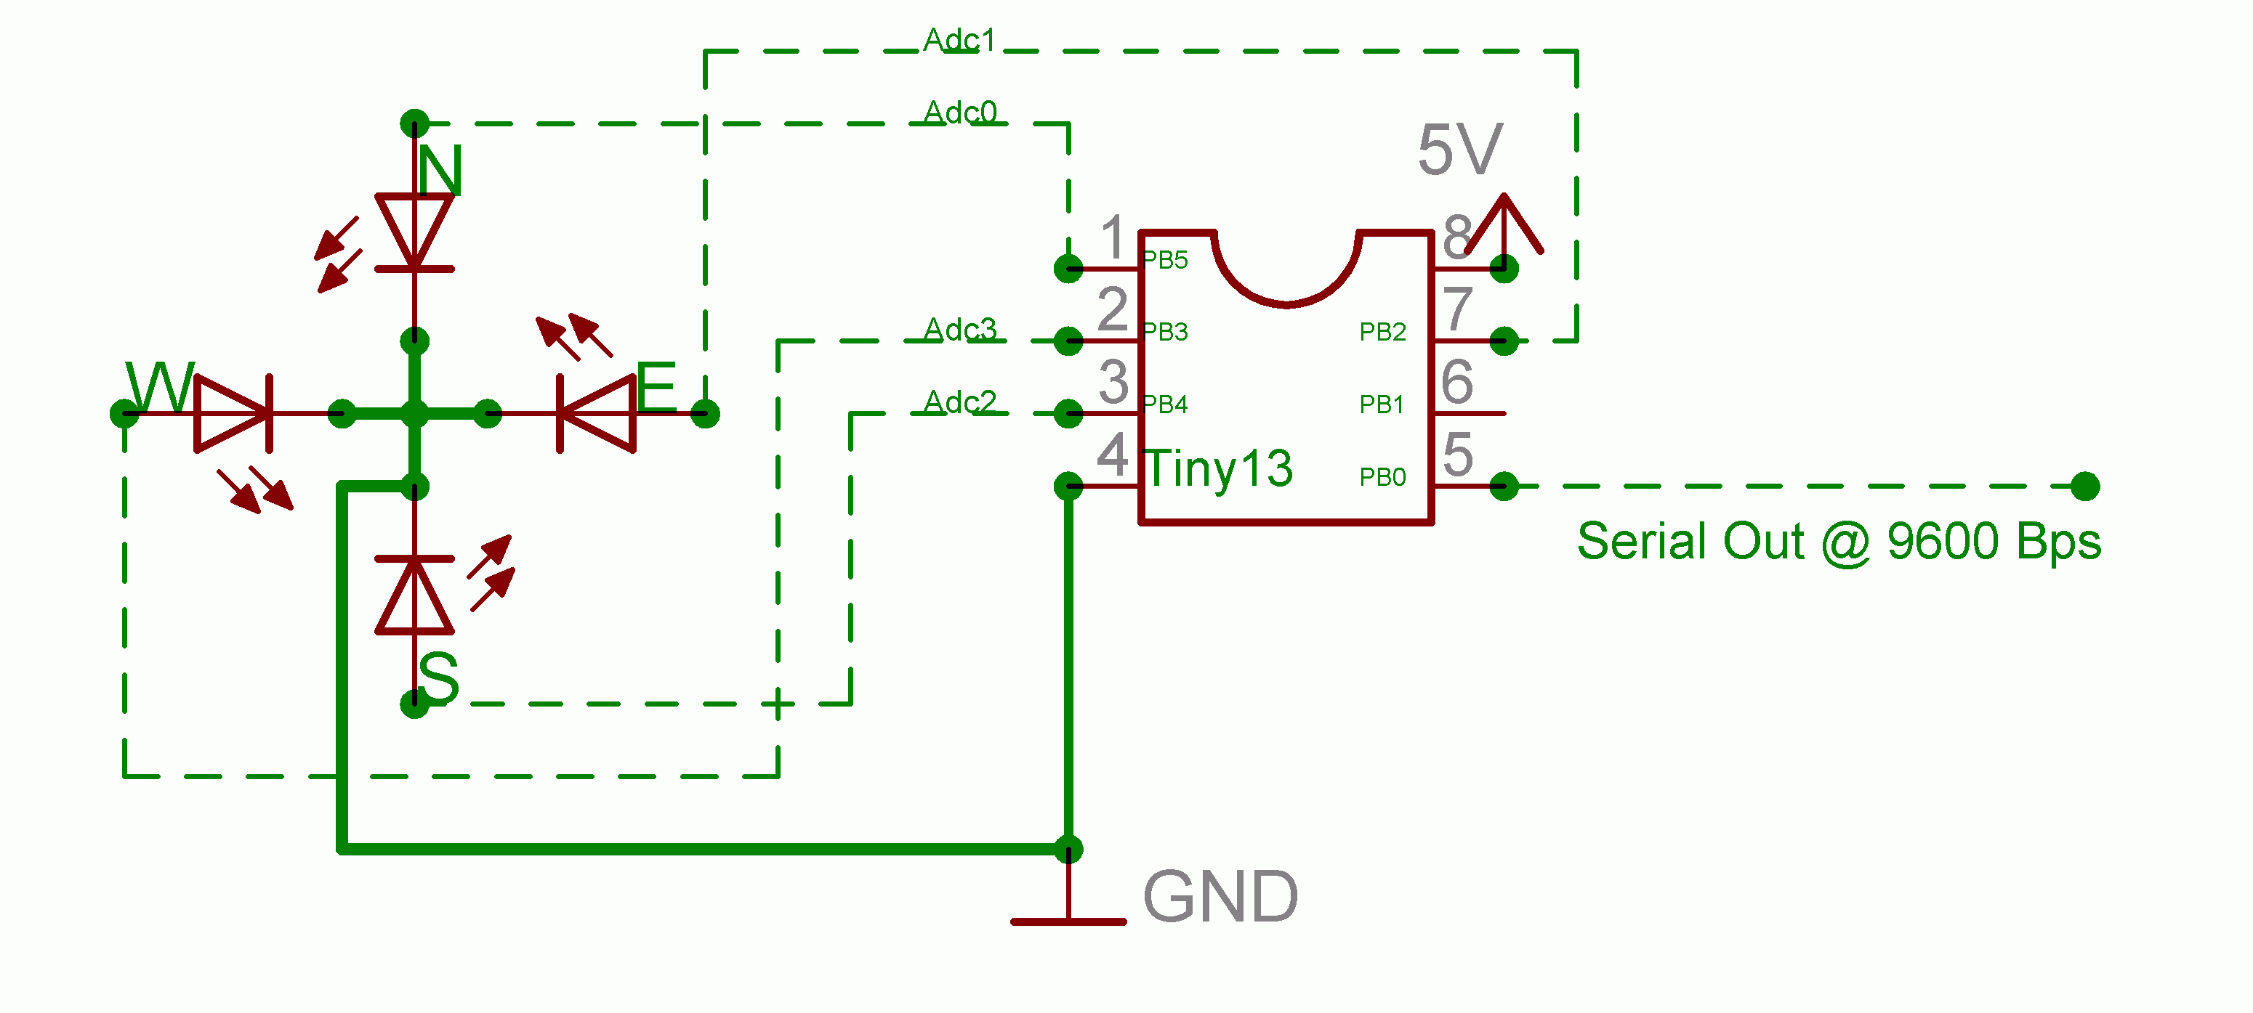
And the Software to run it ? Well the attached “Tracker.asm” may just fit the bill?

Curious ? You can reach me below !

All the best from sunny Germany.

John-Alfred Ullasmann

